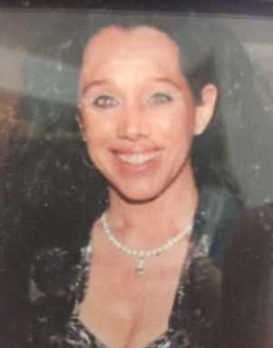
M.Rubina Markopoulou
20, Amerikis Str 10671 Athens, Greece
Tel.: +306982385732 E-mail: rubinam5588@otenet.gr

SUMMARY

Business Matcher/Developer , Architect/Engineer, with a long and successful career in the fields of development and sales. Big experience as a business developer in family hotel business Robinson Club Daidalos, and Robinson Club Lyttos Beach, with international circle of acquaintances and experience in domestic and international business travels.
SKILLS

Excellent interpersonal skills, with the confidence to approach people at all levels of seniority.

Self-motivated and enjoy working to targets.

Articulate, confident communicator and presenter.

Ambitious and persistent.

Commercial knowledge to analyse market data and identify new opportunities.

Strong team player, but equally good at taking initiative.

Numerical skills, to manage large budgets.

Thrive in a pressurized, sales-driven environment

Project management.

WORK EXPERIENCE

2020 - today : President/Founder of the Greek-Moroccan Business
Cooperation Initiative

2018 - today : Representative of Manousos Megalakakis S.A. for business matching regarding olive oil

2017 – today : Founder - President of the Greek – Pakistan Chamber of Commerce and Industry.( Presidential Decree 14/2/2018)

2013-2017 «ATHENA» P.C.C International Business Developing company, Owner and General Director ( business matching )

2012-2013 Yellow Rose S.A., Pharmathen S.A., Kleva S.A., Remedina S.A, Sales Executive Consultant Pharmaceutical laboratories in Iraq, Algeria , Morocco and
Palmiebistro S.A, Βusiness Developer franchise in Iraq.

2009-2011 Adelco S.A, Medhel S.A, Rafarm S.A, Sales Executive Consultant Pharmaceutical laboratories and Drakos-Polemis S.A pumps factory in Arab Gulf region and Africa.

1999-2011 Constructions with engineer Gianni Lazarou.

2007-2009 Geniki Emporiki S.A Consultant for international Business Projects.

2005-2007 Advisor to the Ambassador of Nigeria, in Athens.
Business Developer Consultant in Nigeria.

2001-2004 Ministry of Culture, Consultant of the Minister for the
Olympic games of Athens 2004.

2000-2003 Georgiades S.A., Explorer S.A., G–Systems S.A. Communications Consultant in the gulf area.

1998-2000 Euroxx S.A Stock market company, Key Account Manager.

1995-1998 Telegroup American telecommunication services company in Paris, Sales department, Business Development Supervisor for Greece and Balkan area.

1990-1995 Αstir Palace Elounda beach Crete & Astir Palace Paris, Public relations department, representative in Paris.

1988-1990 Hellenic Embassy in Paris, Consultant in the commercial department.

1987-1988 Lalaounis store in Paris, Sales department, Sales Coordinator.

REWARDS

Prize of cooperation from the Government of Iraq, for the construction of school and hospital in Sala Ahadin.
Several Rewards for signng MOUs with different Chambers of Commerce and Industry in Pakistan

EDUCATION

Graduated from Moraitis School of Athens
University studies : Special School of Architecture in Paris, Bachelor degree in Architecture-Engineering 1985.

LANGUAGES

English (native speaker).
French (native speaker).
Italian (independent user).

COMPUTER SKILLS

Microsoft office (Windows OS, Microsoft Excel, Word, Outlook, PowerPoint).

REFERENCES

Available upon request.

